
CSPE65: MACHINE LEARNING TECHNIQUES AND PRACTICES

Assignment - 2
106119100 - Rajneesh Pandey


Problem Statements

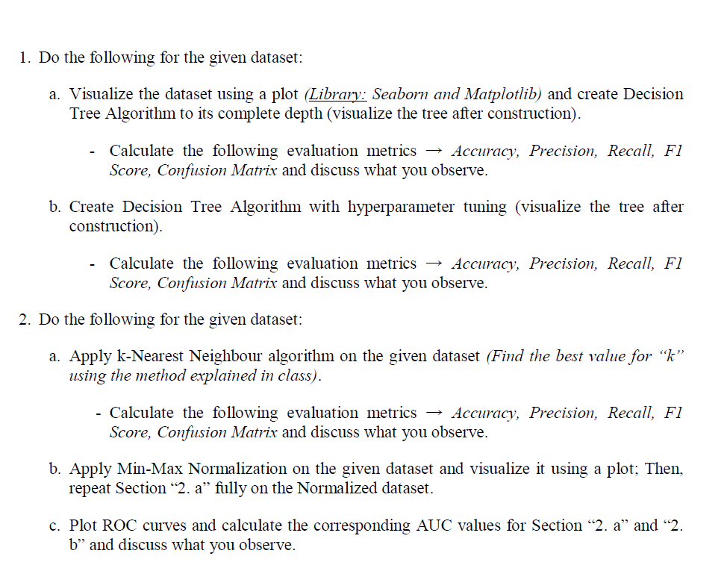

Code is written on Kaggle Notebook

Link of the notebook : https://www.kaggle.com/rajneesh1708/106119100-ml-assignment-2/edit

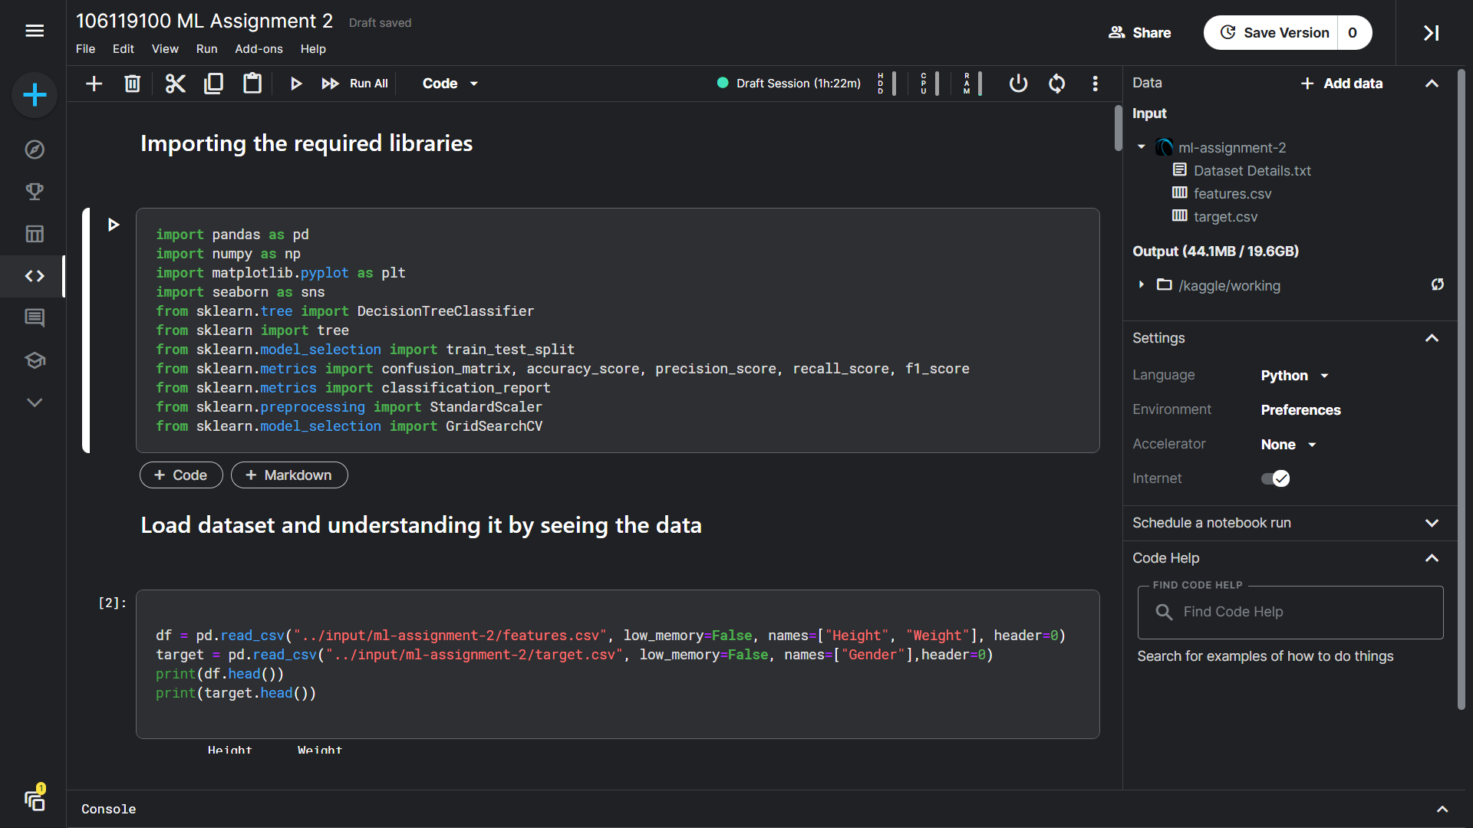

Importing the required libraries

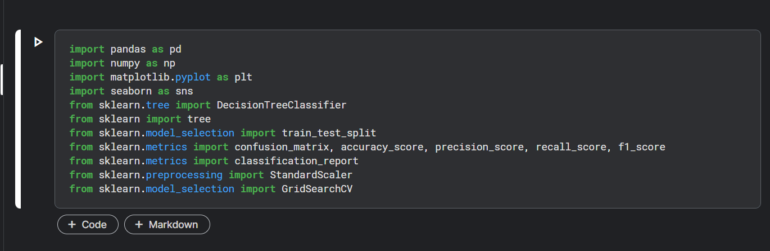

Load dataset and understanding it by seeing the data

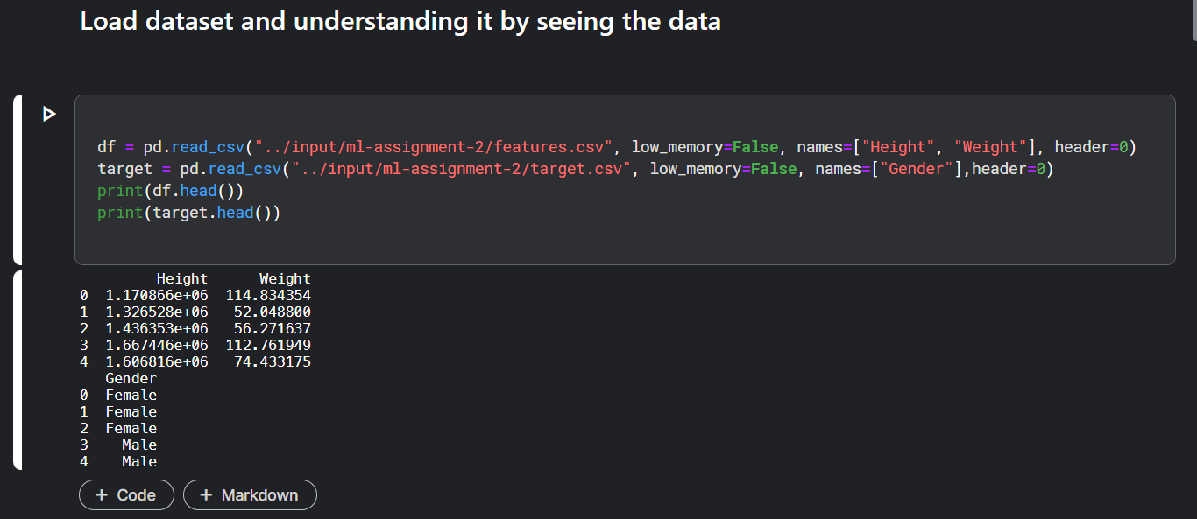

Checking for rows duplicate
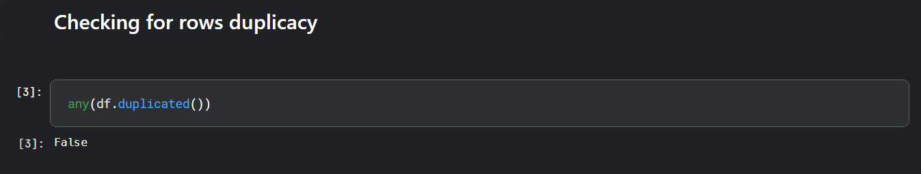
Mapping the target variables, for Male as 1 and Female And checking the replacement done.
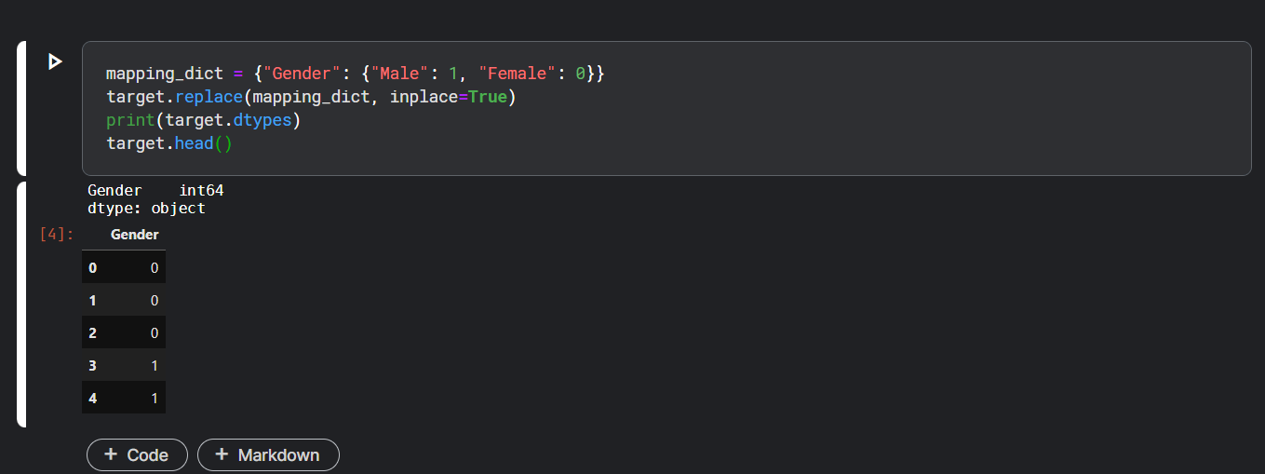
Checking the outliers present in the dataset by using Box and Whiskers Plot

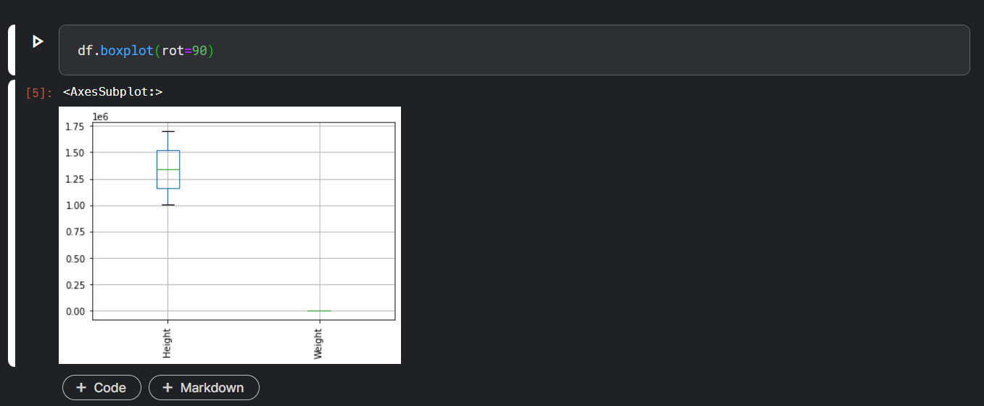

Scatter Plot

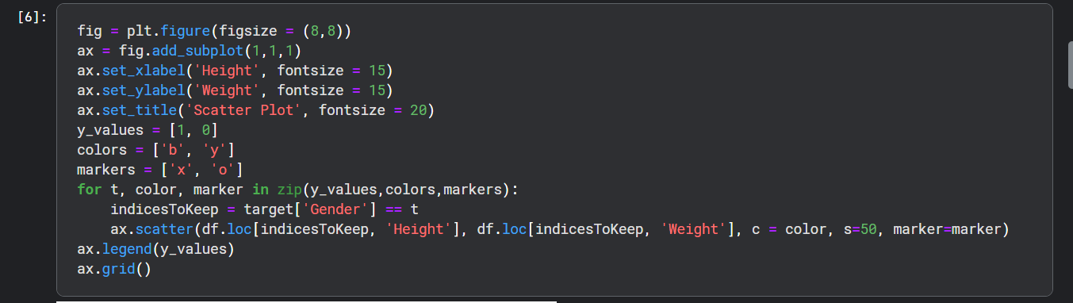
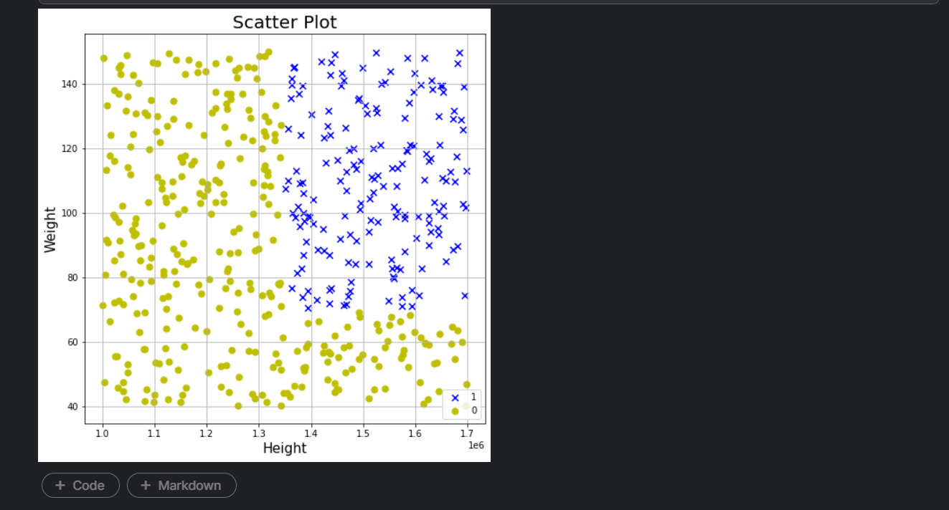

Split our dataset into training and testing dataset in the ratio of 80-20 respectively.

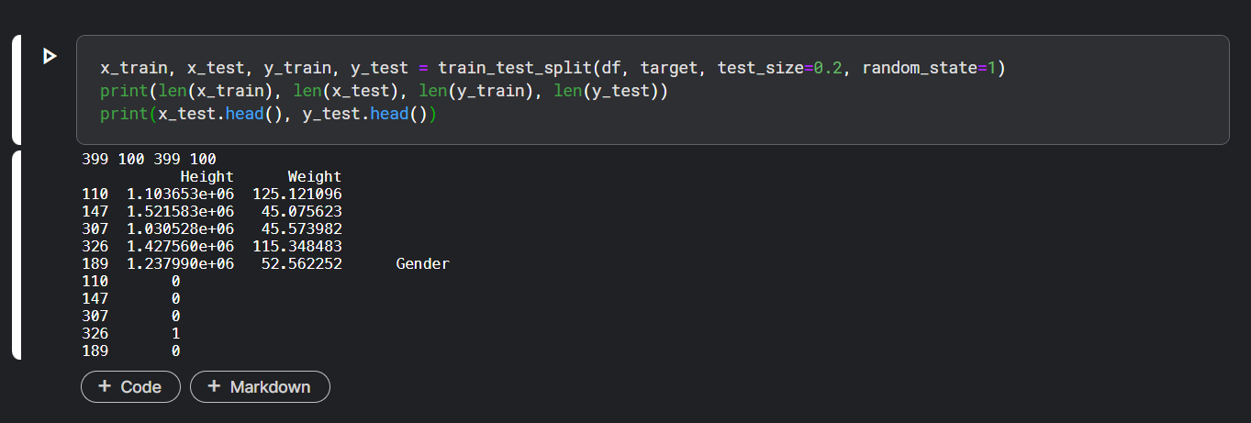

Check for class imbalance i.e. we have data belonging to both the classes in training and testing dataset

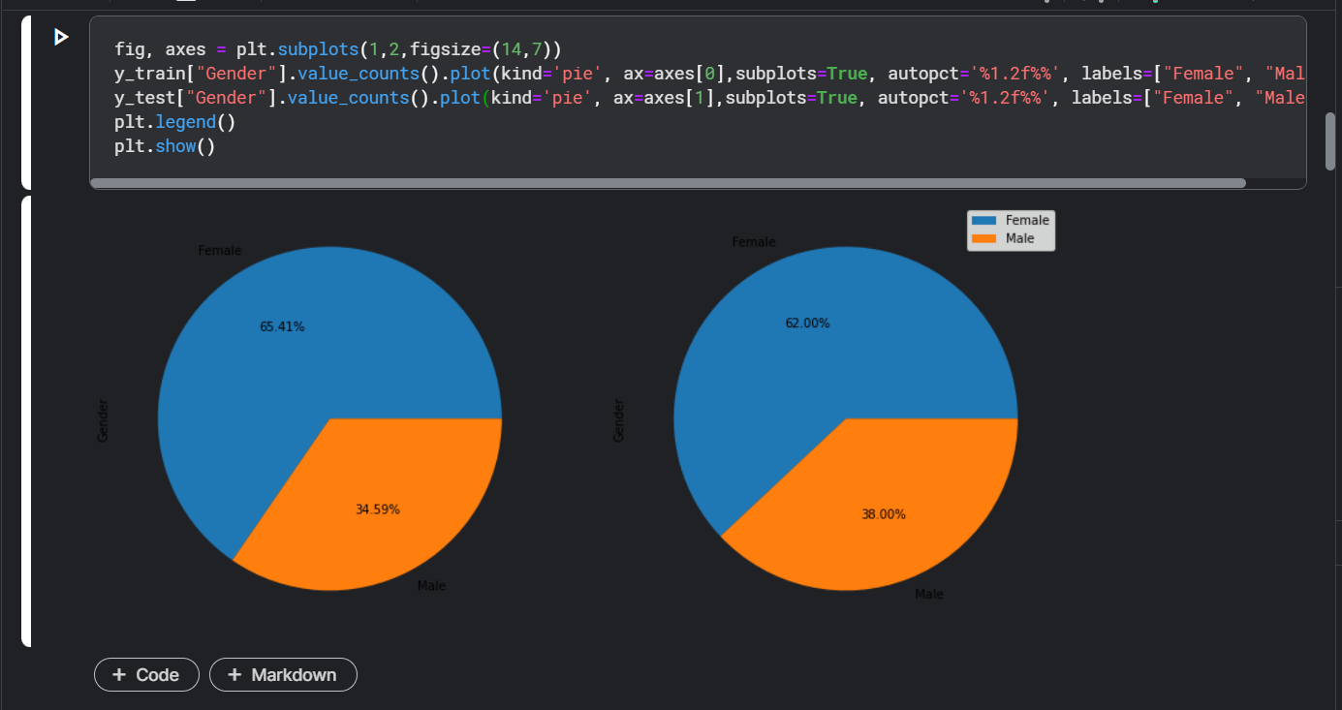

As I can see from the plots, both the classes are split in appropriate proportions. So our model will not become biased after training.

Question 1A and 1B

Intialising the DecisionTreeClassifier

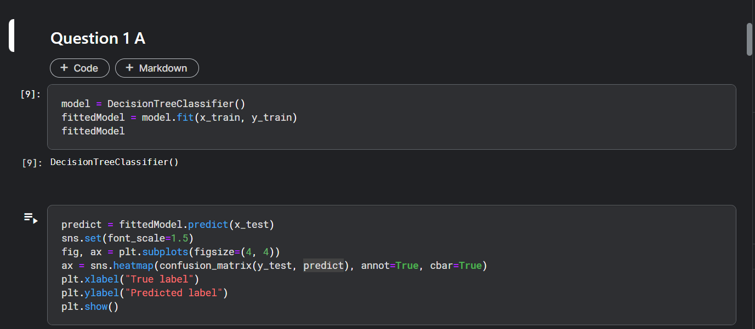

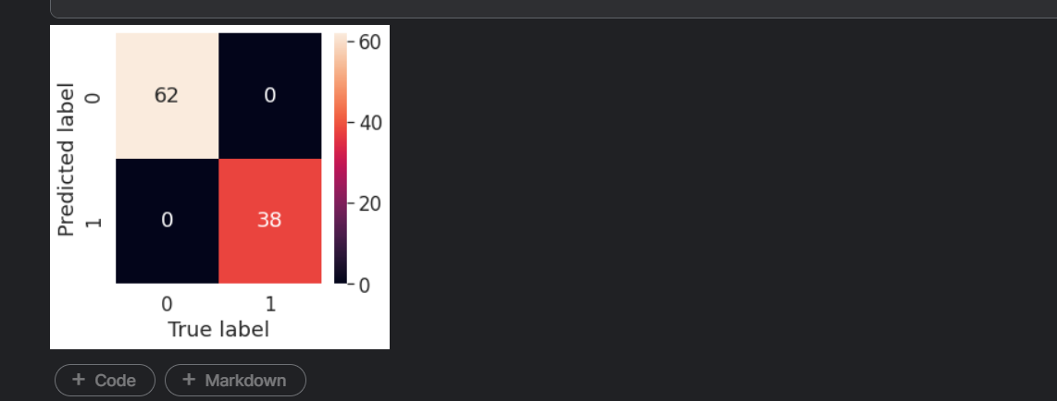

Printing the required evaluation metrics (1A)

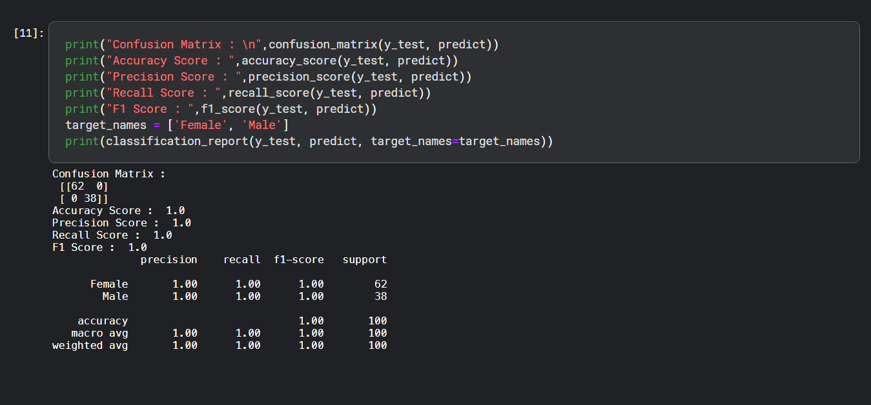

As we can see from the evaluation metrics, the model has an accuracy of 100% even without hyperparameter tuning. Since this is a small and easy dataset, we were able to get a 100% accuracy. But this need not be true for complex datasets.

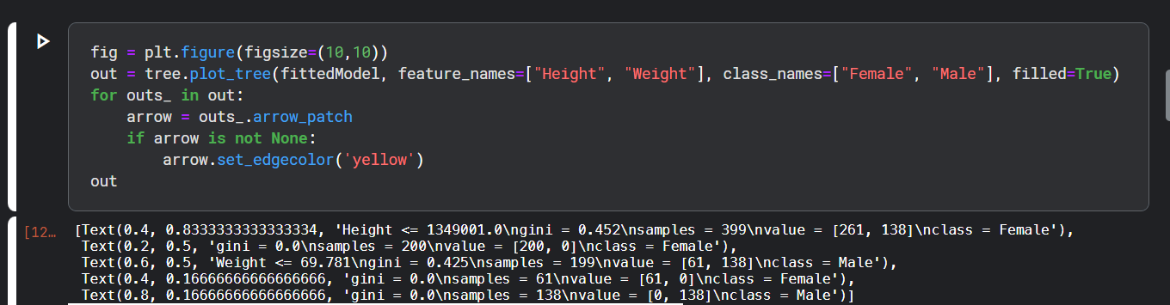

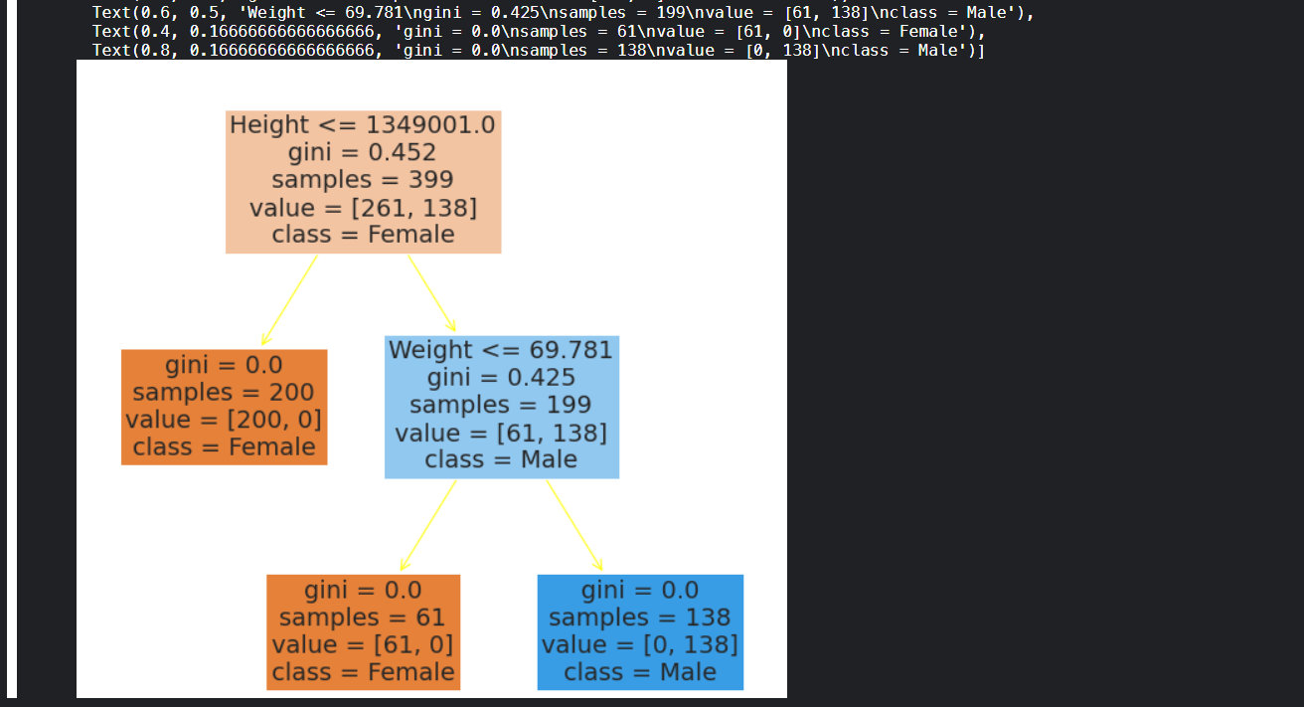

This is the obtained Decision tree
gridsearchCV is used to tune the hyperparameters.
'min_impurity_decrease' is an efficient parameter to prevent overfitting of the model.

Question 1 B

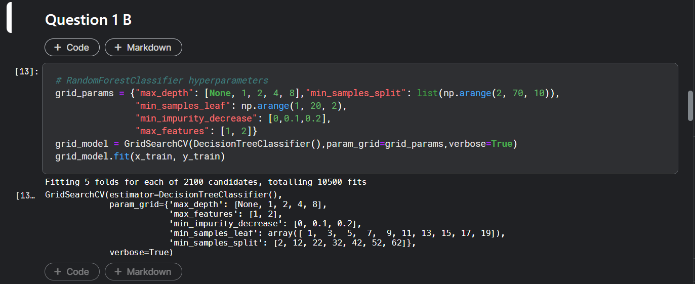

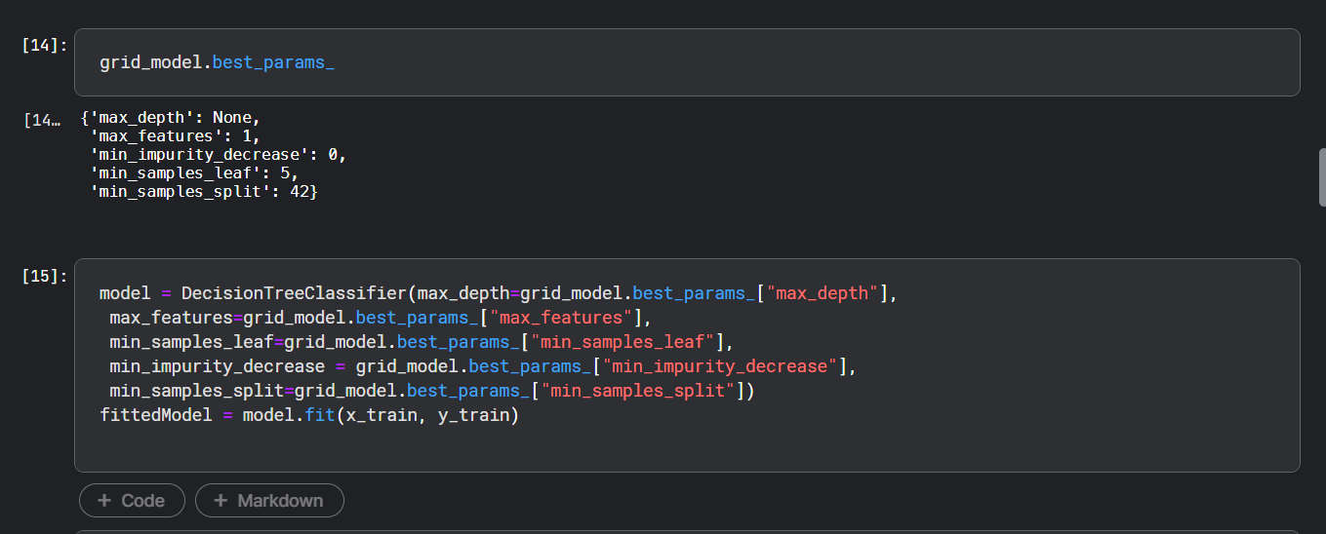

Heat map
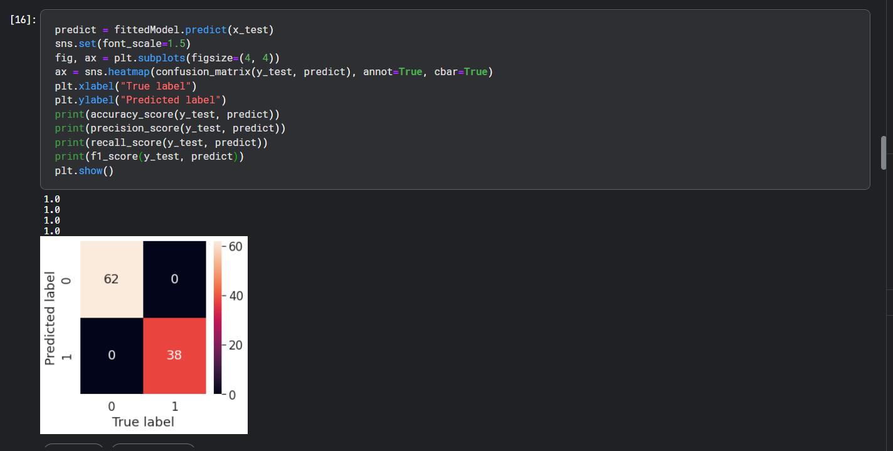

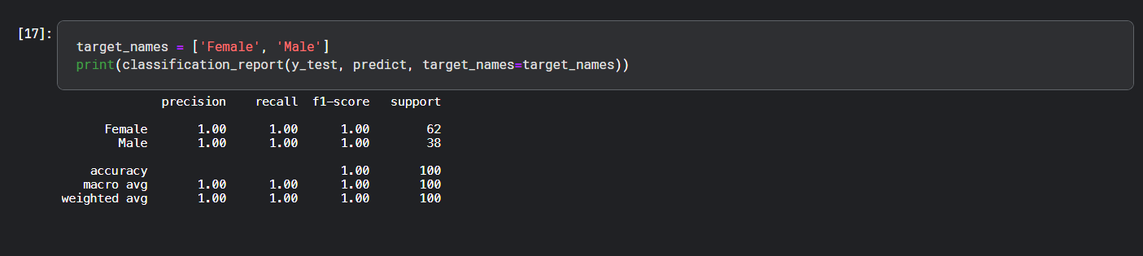

Here we got the same accuracy for both the trees.
But, for new complex real time data, this hyperparameter tuned decision tree may perform better

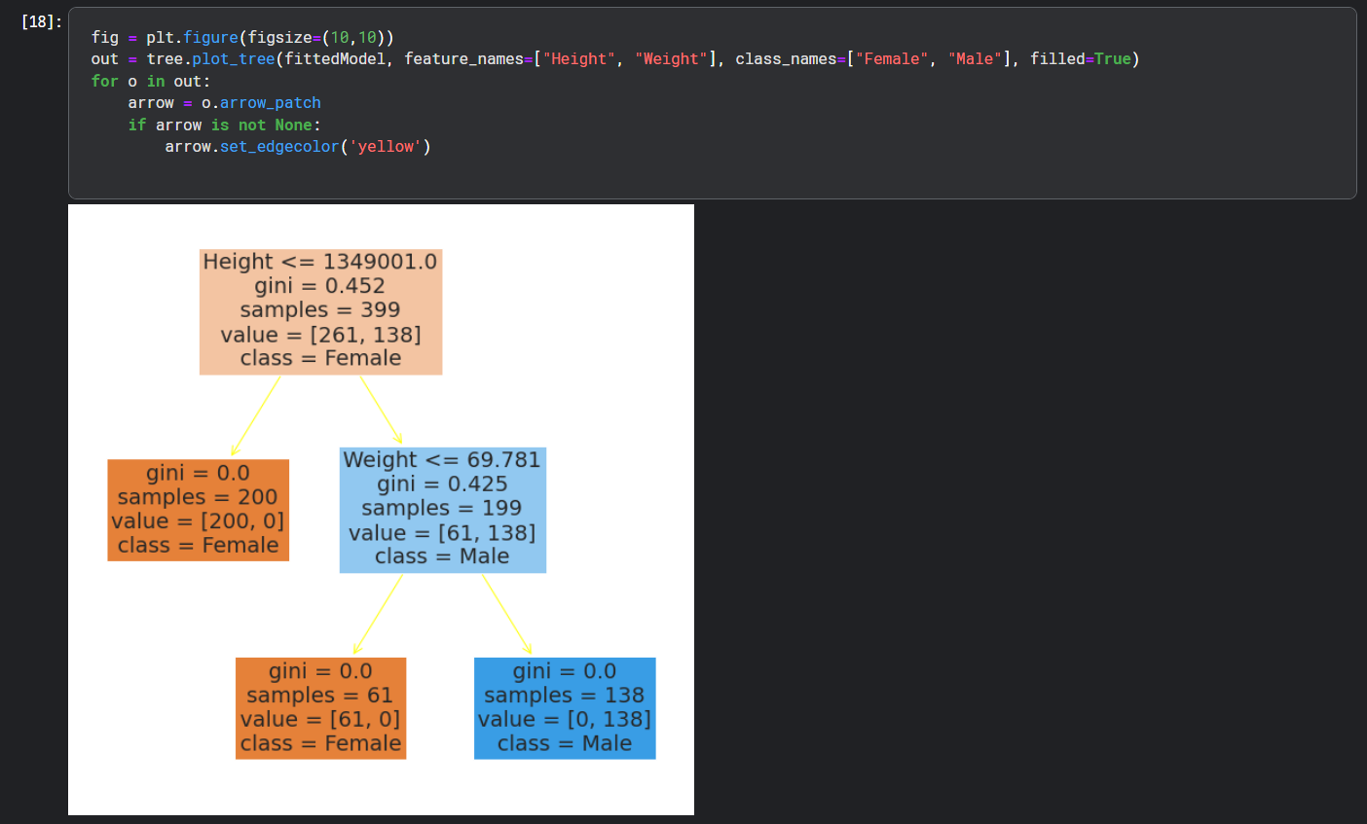

Reshape y_train and y_test to a one dimensional numpy array to suit KNN input format (avoid warnings)

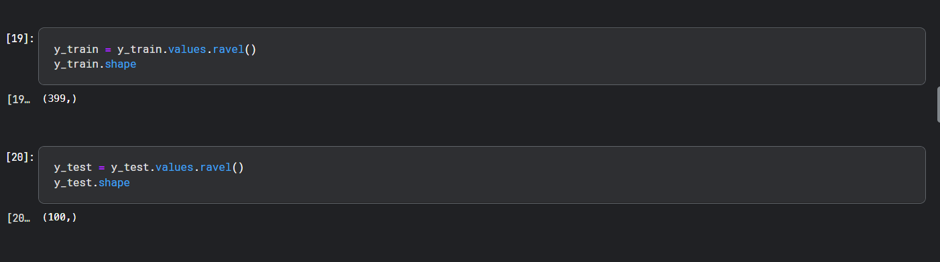

Question 2A
Implementation of KNN
1. Import necesaary class from sklearn
2. Initialise model
3. Fit model on training dataset

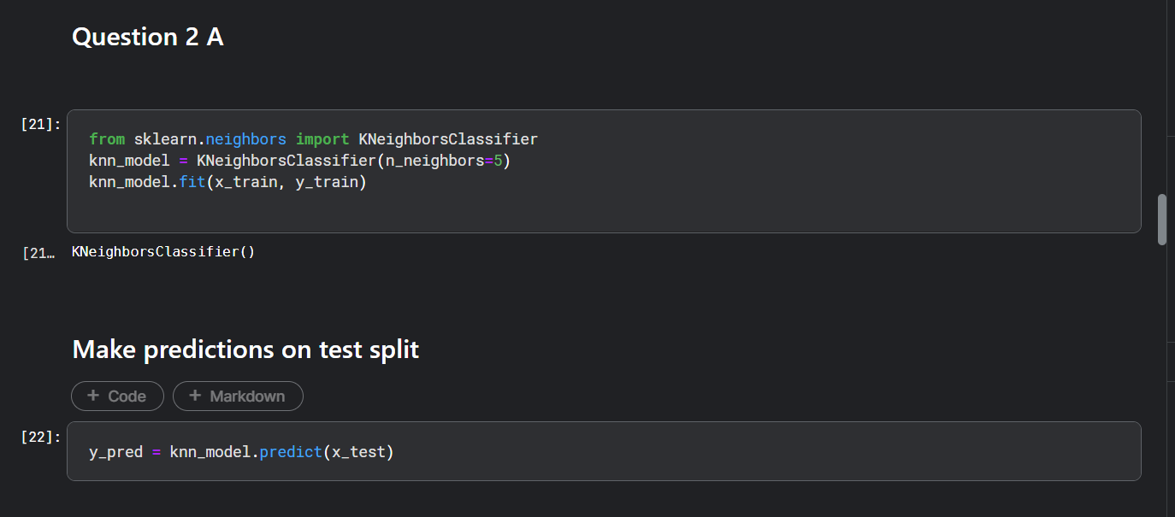

Evaluating the model-confusion matrix and classification report

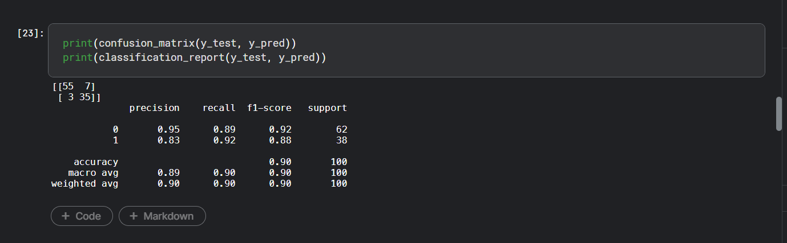

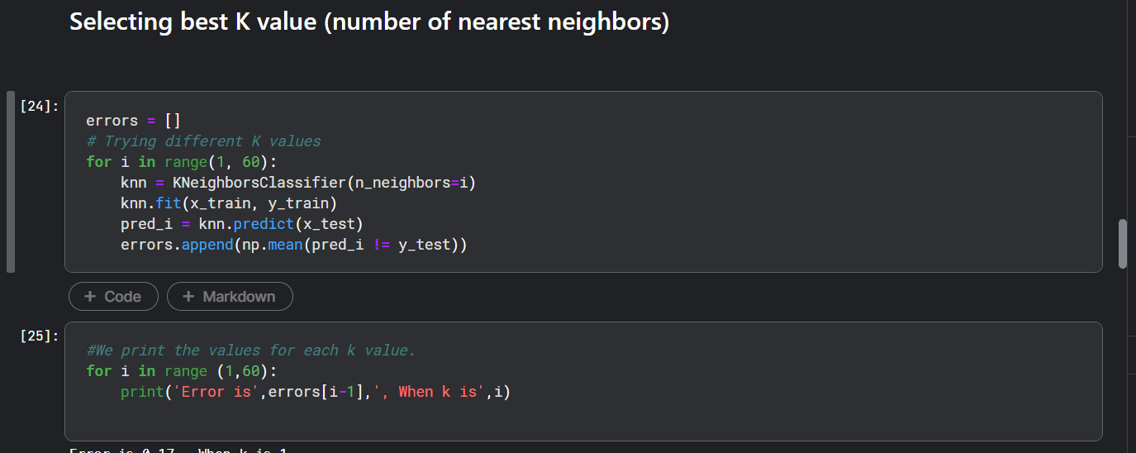

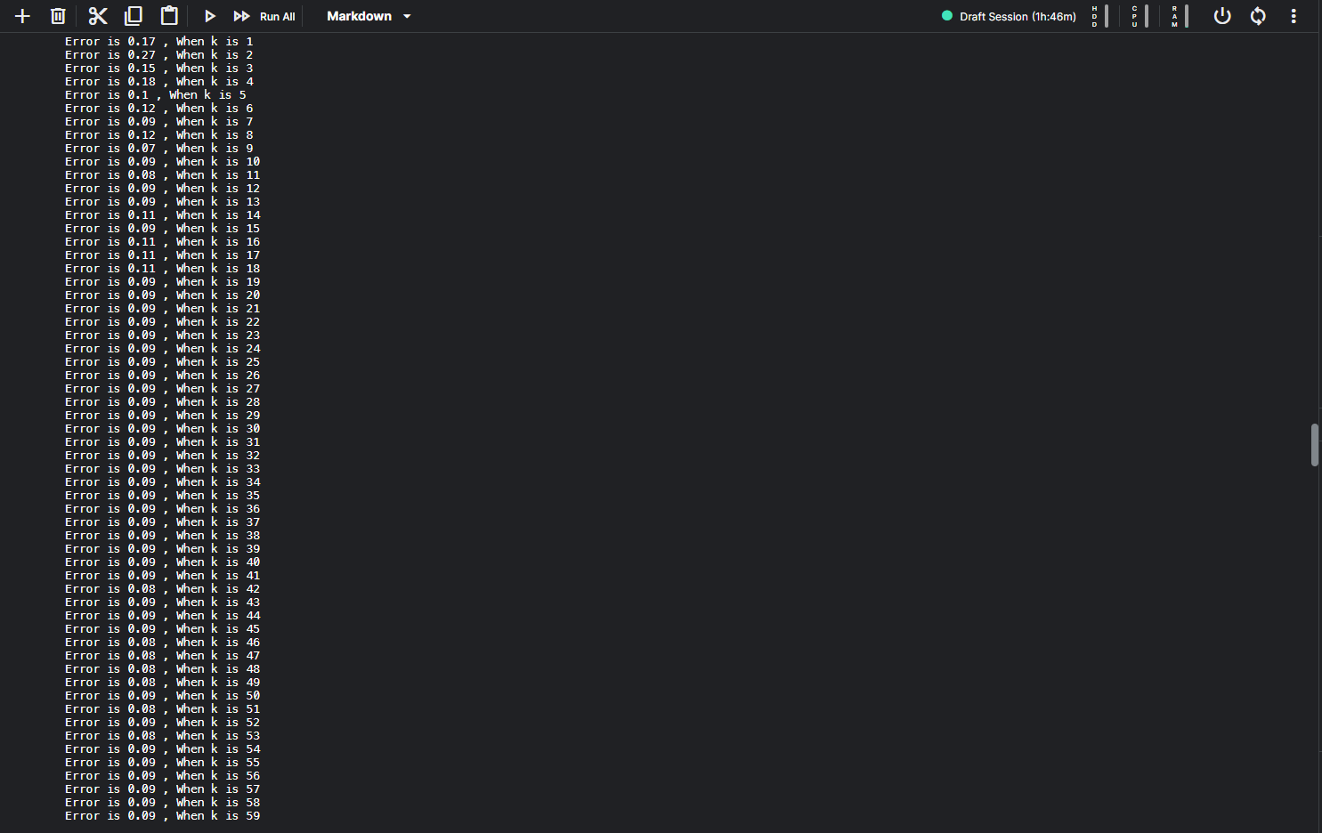

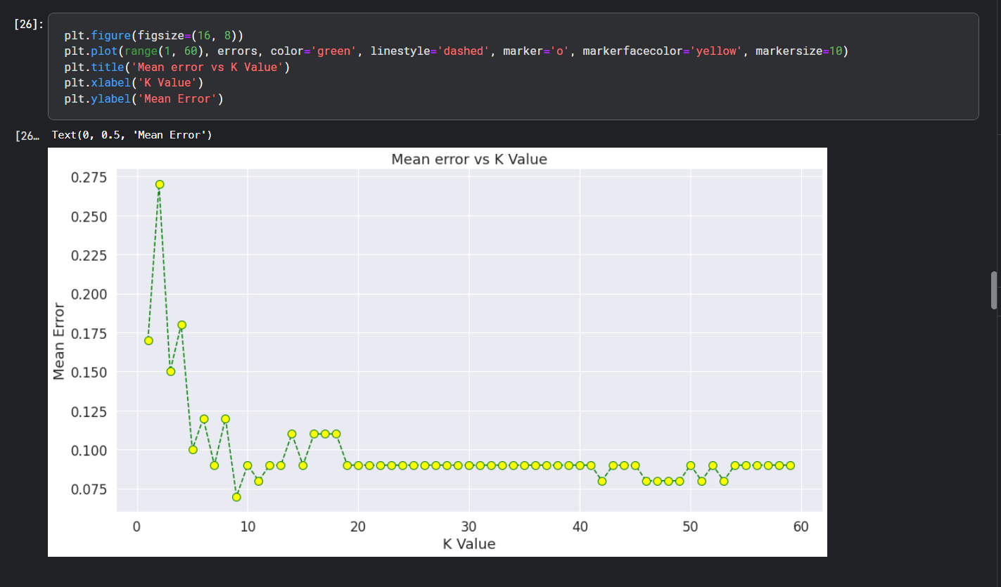

Creating a new model with n_neighbors parameter as 25

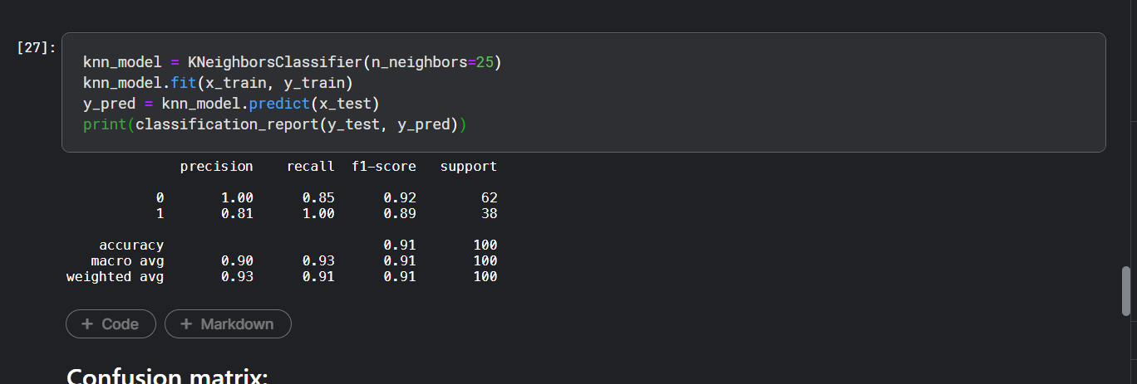

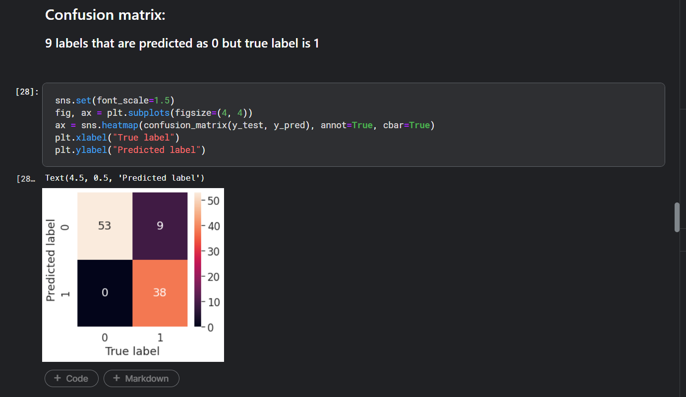

Visualising the dataset (data points under each target class) before normalization
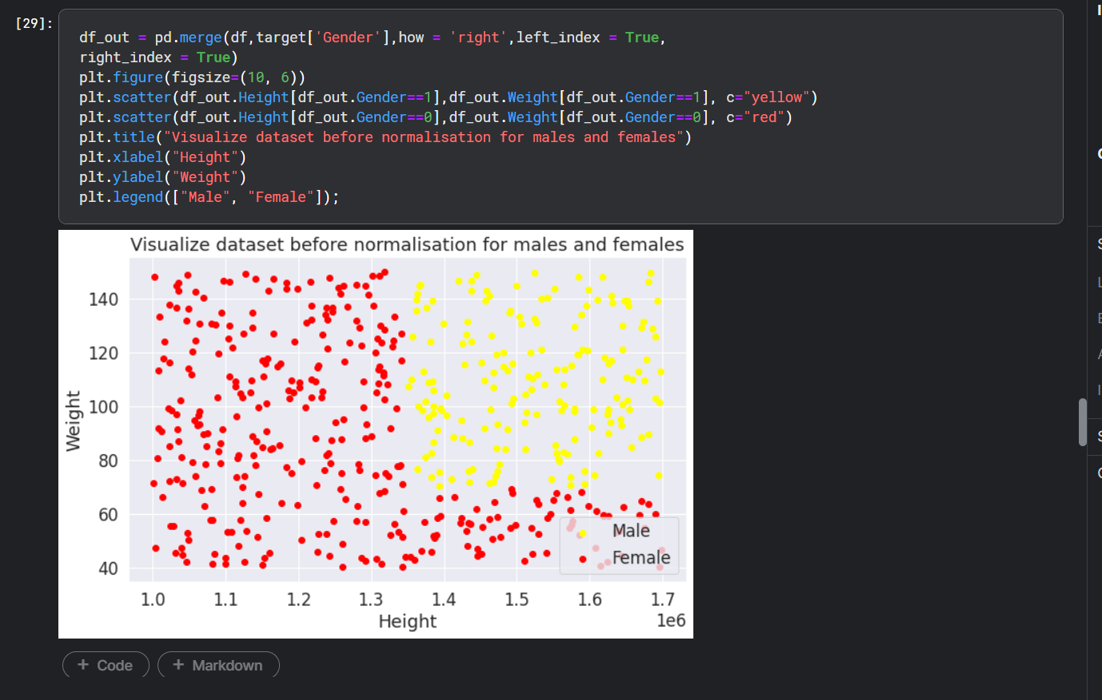

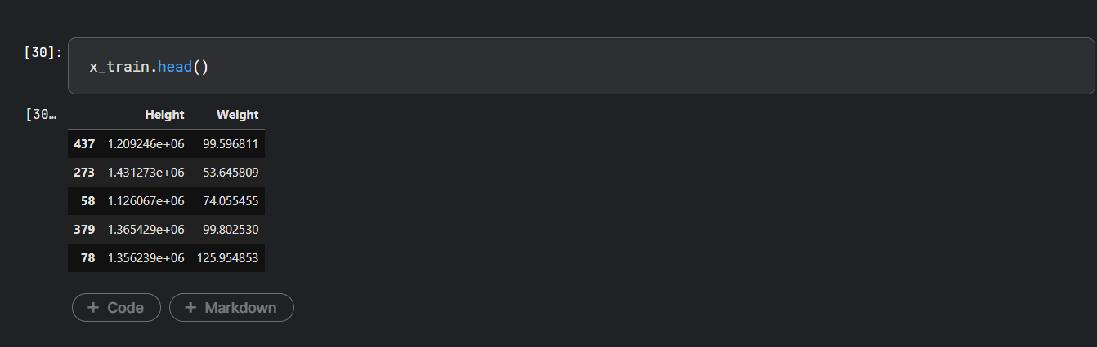

Question 2 B

Min-max normalisation
Use same scalar we used for the train split to transform the test split

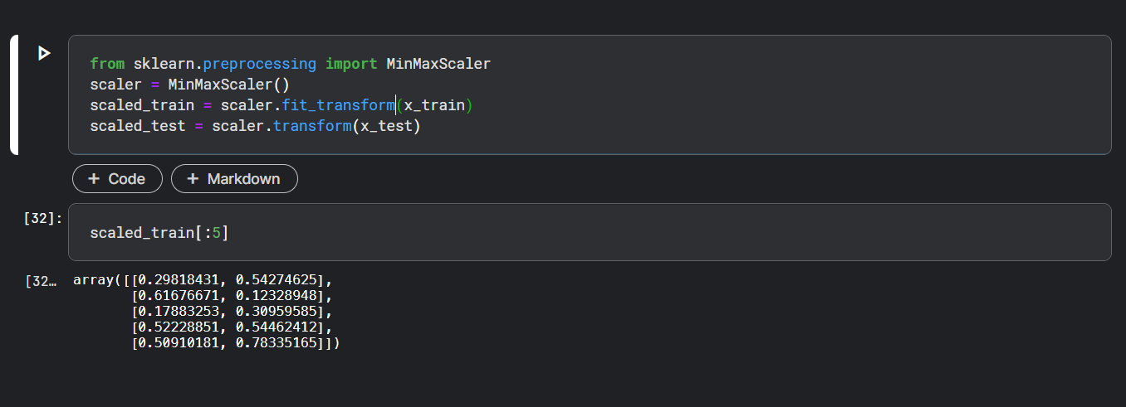

Visualizing data points after normalization

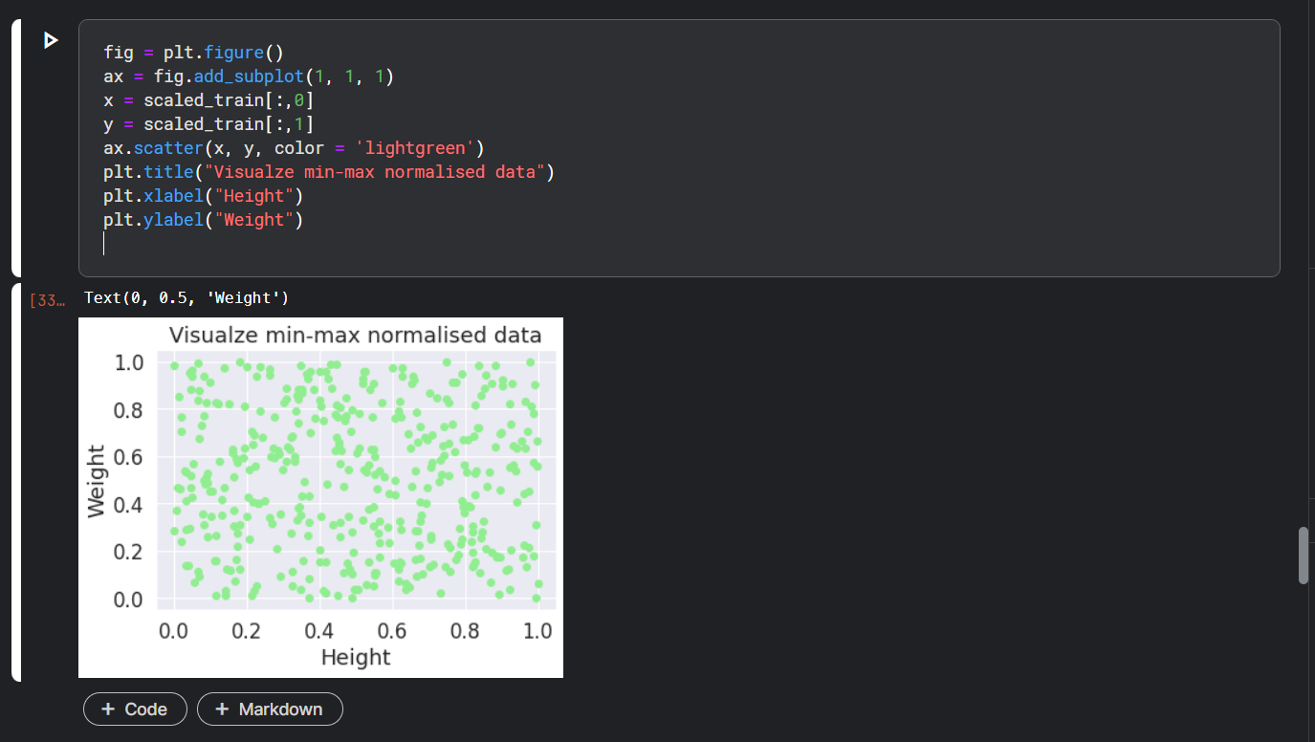

finding the optimal K value by plotting the error vs K value. But this time I use the normalised dataset to train the model

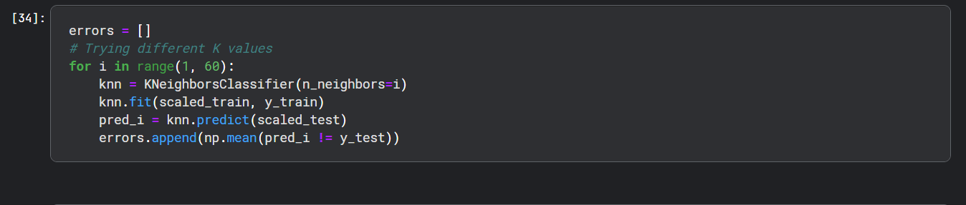

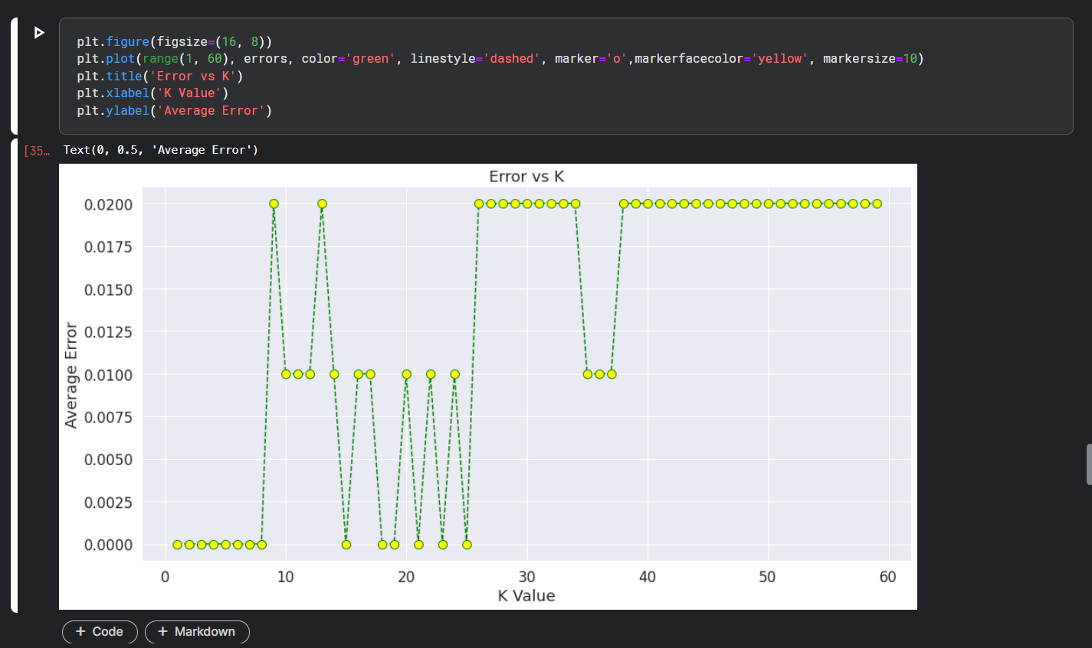

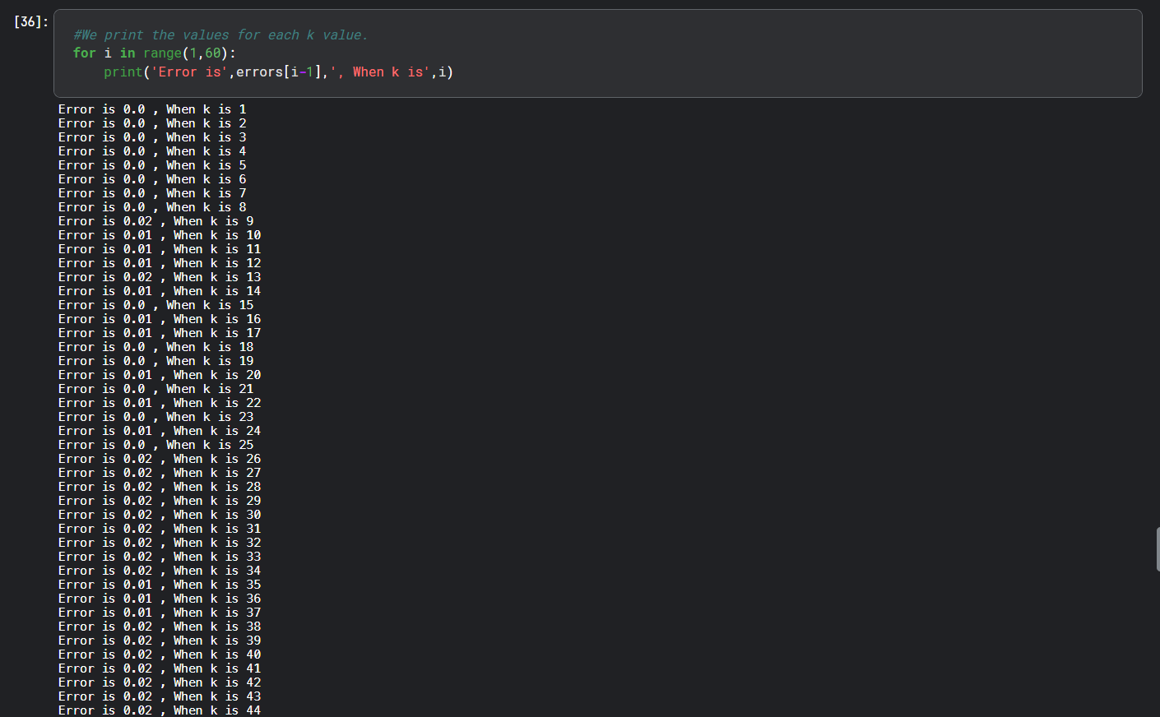
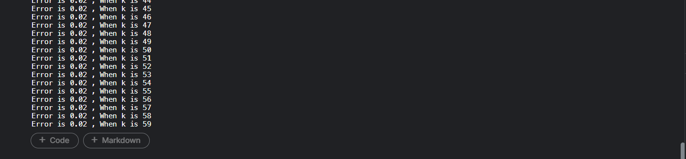

K=5 is the optimal value as obtained from the above graph.
Now I will create a new model with n_neighbors tuned to 5

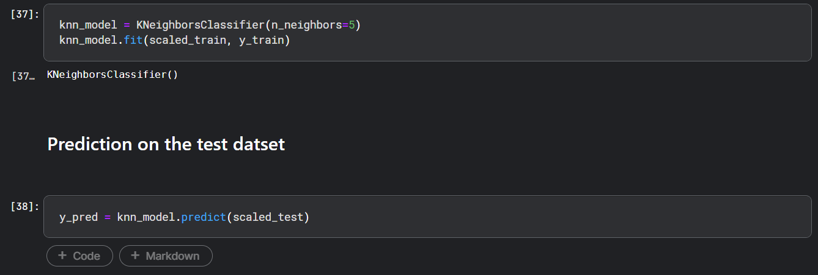

Classification Report and confusion matrix of the predicted values

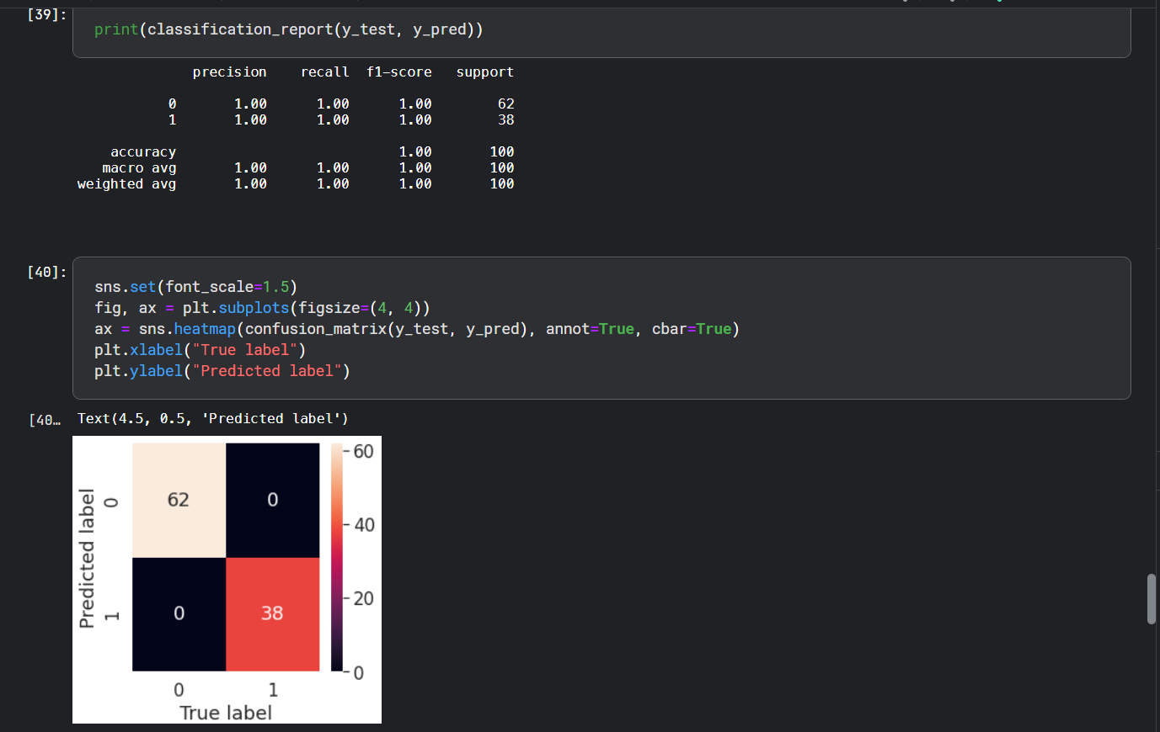

Again Using gridsearch to find the best parameters (like for n_neighbors)

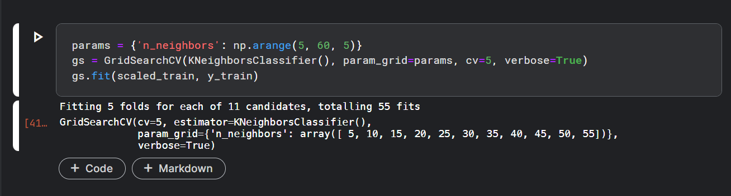

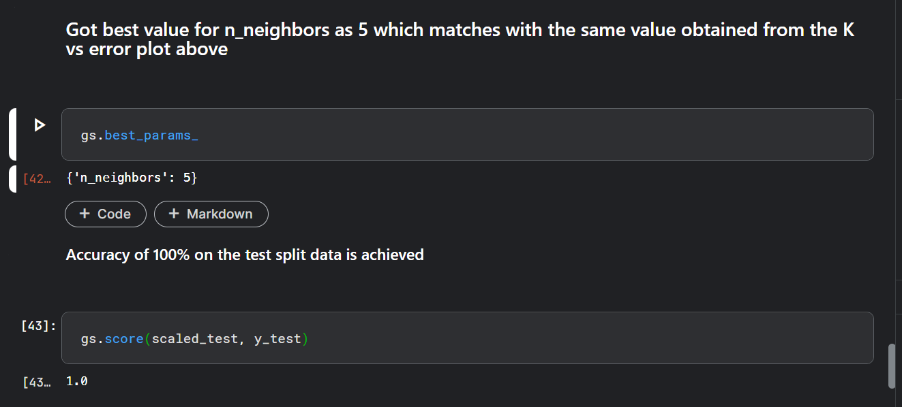

Question 2C

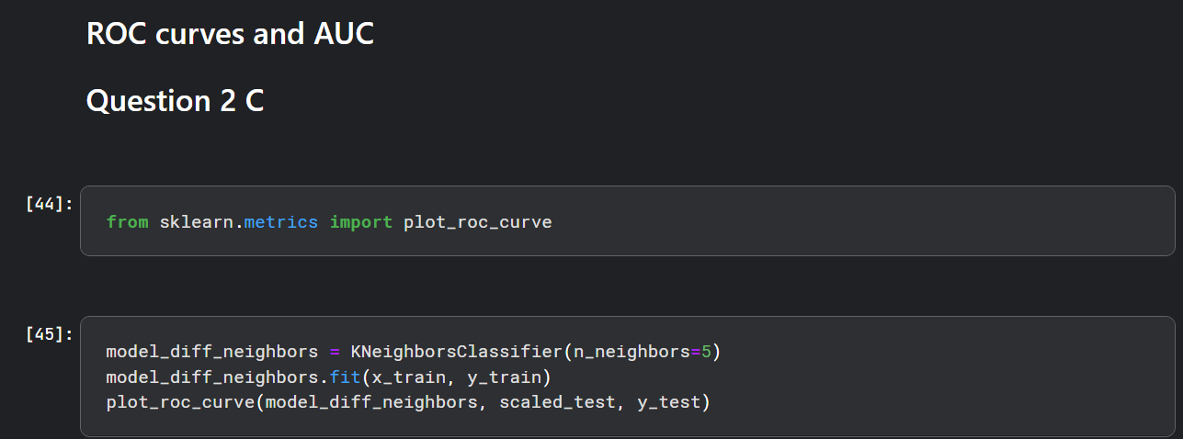

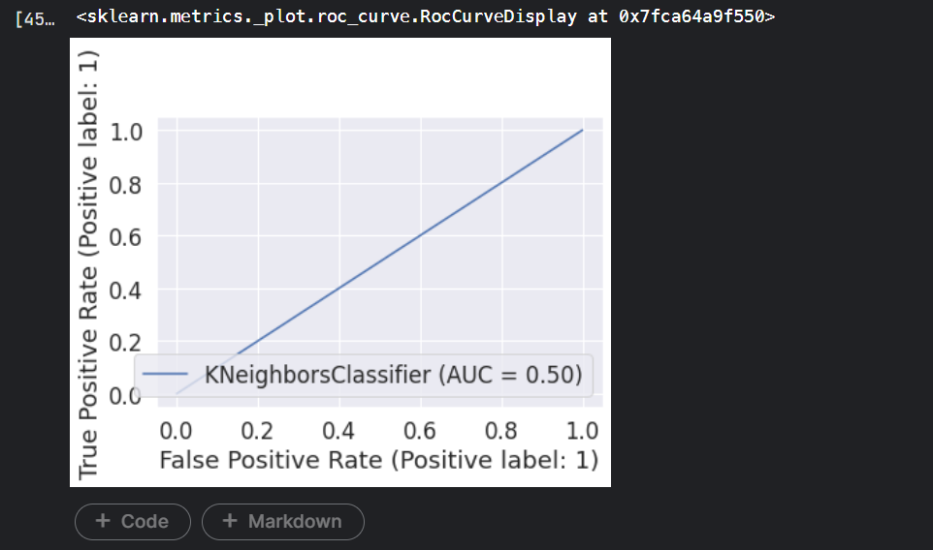

Got slightly bent roc curve (AUC not exactly one - rounded off in the plot) if I use different number of n_neighbors like 11 as the best hyperparameter is 5 for n_neighbors
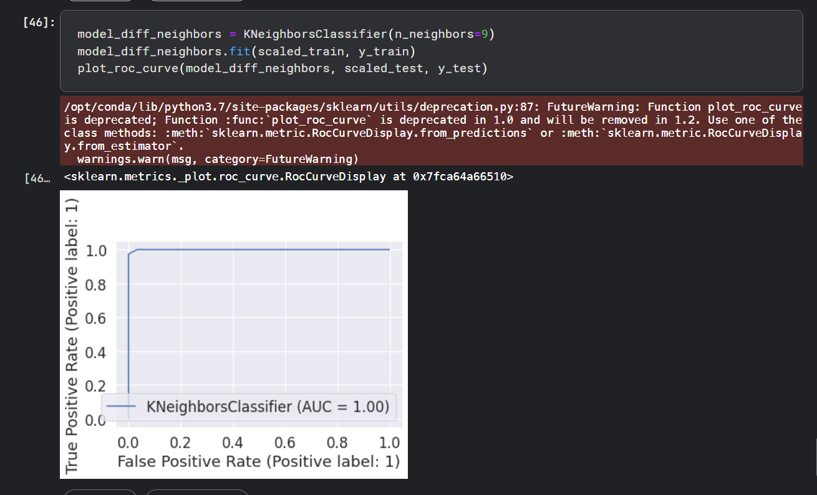
Perfect ROC curve
Perfect plot with well tuned hyperparameter(n_neighbors=5) and fitted on normalised data. AUC is one, hence this is the most optimum solution
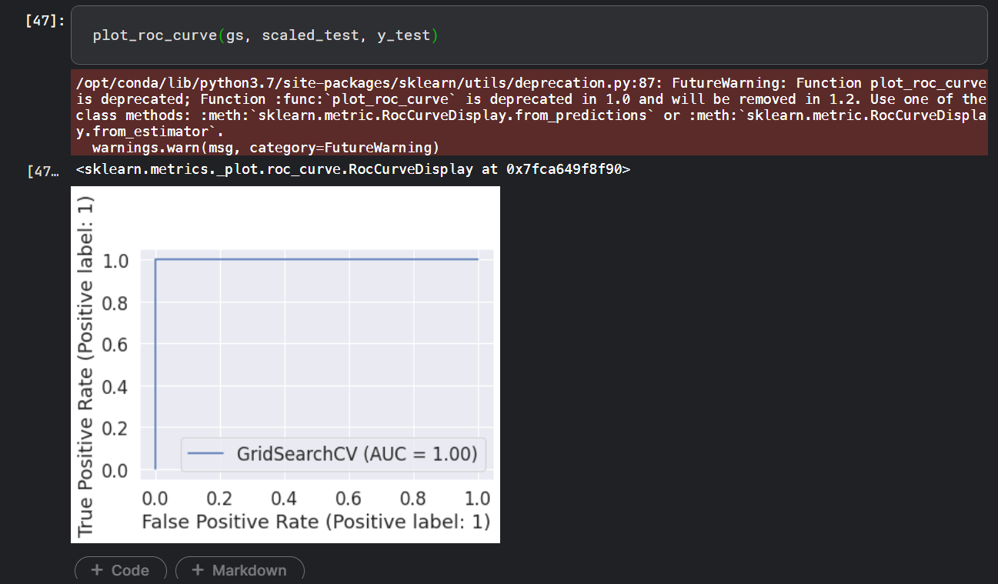

Thankyou

